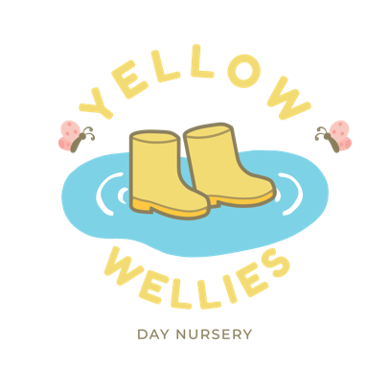

Yellow Wellies Durham
Nursery Fees 2026 -2027

0 – 3 years
Full Time (Mon – Fri) | 8:00am – 6:00pm | £380.00
Full Day | 8:00am – 6:00pm | £83.95
Morning | 8:00am – 1:00pm | £52.50
Afternoon | 1:00pm – 6:00pm | £52.50
3+ years
Full Time (Mon – Fri) | 8:00am – 6:00pm | £375.00
Full Day | 8:00am – 6:00pm | £82.95
Morning | 8:00am – 1:00pm | £48.50
Afternoon | 1:00pm – 6:00pm | £48.50

The above prices are inclusive of meals.

There is a non-refundable registration fee of £50.00 required to secure your place.
*terms and conditions apply

* A minimum of two sessions per week is required for every child.
* Fees are due within the first 7 days of the month.
* There is a 10% reduction for siblings. Terms and conditions apply.
* Late pick up’s will be charged at £15 initially then £10 every 15mins.
* Failure to pay childcare fees will result in a payment charge of 20% being added to your account.

Yellow Wellies Durham
Nursery Fees – Term Time only 2026 -2027

The above prices are inclusive of meals.

0 – 3 years
Full Day | 8:00am – 6:00pm | £86.00
Morning | 8:00am – 1:00pm | £52.95
Afternoon | 1:00pm – 6:00pm | £52.95
3+ years
Full Day | 8:00am – 6:00pm | £84.95
Morning | 8:00am – 1:00pm | £49.50
Afternoon | 1:00pm – 6:00pm | £49.50

There is a non-refundable registration fee of £50.00 required to secure your place.
*terms and conditions apply

* A minimum of two sessions per week is required for every child.
* Fees are due within the first 7 days of the month.
* There is a 10% reduction for siblings. Terms and conditions apply.
* Late pick up’s will be charged at £15 initially then £10 every 15mins.
* Failure to pay childcare fees will result in a payment charge of 20% being added to your account.

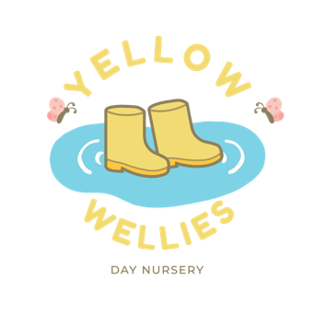
Yellow Wellies Durham
Funded Options

Term Time:
- 9-month funding - 15 hours per week, 38 weeks of the year
- 2-year-old funding – 15 hours per week, 38 weeks of the year
- 3&4 year old funding, 15/30 hours per week, 38 weeks of the year

All Year Round:
- 9-month funding – 11 hours per week, 51 weeks of the year
- 2-year-old funding – 11 hours per week, 51 weeks of the year
- 3&4 year old funding – 11/22 hours per week, 51 weeks per year

Offer 1 | Time  9am – 12pm  1pm – 4pm  9am – 3pm (TTO) | Hours Used  3 hours  6 hours | Cost  Free
Offer 2 | Time  8am – 1pm | Hours Used  5 hours | Cost  £14
Offer 3 | Time  1pm – 6pm | Hours Used  5 hours | Cost  £14
Offer 4 | Time  8am – 6pm | Hours Used  10 hours | Cost  £21
Offer 5 | Time  7:30am – 1pm | Hours Used  5.5 hours | Cost  £15
To maintain high standards and additional learning experiences, we charge a contribution towards our enrichment offer.

Enrichment Offer: Government funding covers the basic cost of early years education but does not include:
- Meals and snacks
- Enhanced provision (resources, specialist teaching)
- Celebrations, outings, or seasonal activities
- IT Access and family support initiatives

If you require a 7:30am start please note there is an additional charge for this.
Reference: Please put your child’s full name

Bank Details:
Account Name: Daypark LTD
Sort Code: 30-93-71
Account Number: 10800062

